**Causal Loop Diagram (Systems Thinking Map)**

The following causal loop illustrates how communication practices by IT supervisors directly impact team morale and performance outcomes:

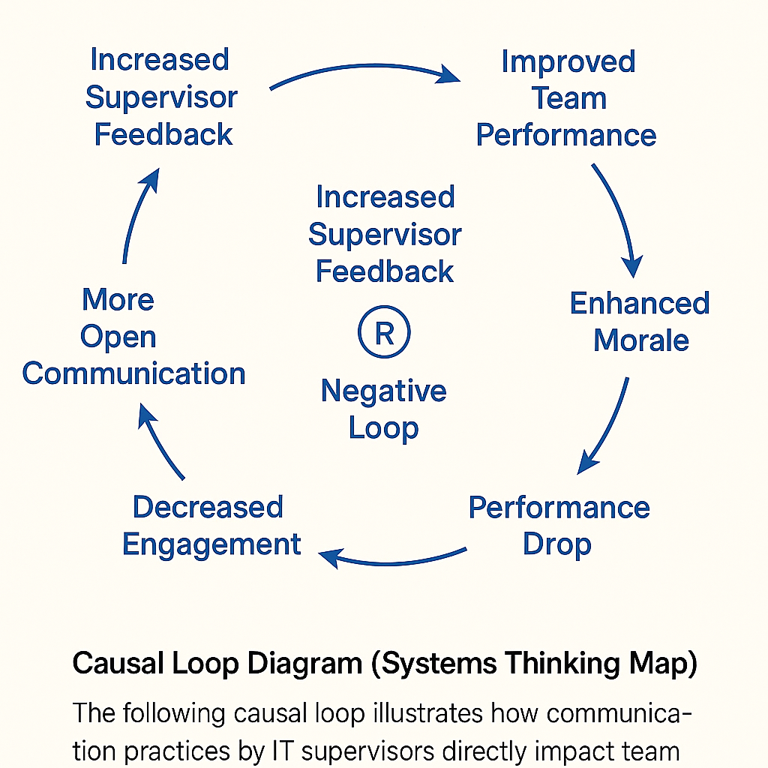

* **Positive Loop**: Increased Supervisor Feedback → Higher Engagement → Improved Team Performance → Enhanced Morale → More Open Communication
* **Negative Loop**: Lack of Feedback → Decreased Engagement → Performance Drop → Employee Frustration → Communication Breakdown

This model reflects the systems thinking approach introduced by Senge (2006), emphasizing that small changes in communication frequency and quality can create ripple effects across the team’s dynamics. It serves as a leadership diagnostic tool for maintaining team alignment and fostering a culture of continuous feedback.

**Reference**:

Senge, P. M. (2006). *The fifth discipline: The art & practice of the learning organization*. Currency/Doubleday.